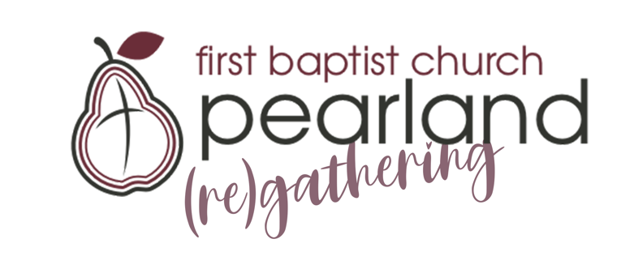
Small group leader

We are excited about the possibility of (re)gathering in-person as a church family. Our hope/goal for this is September 13. Knowing this date is on the horizon, we are allowing small groups to begin gathering on-campus in August. If your small group would like to use the church as a gathering space in August, there are a few things we want you to know to help you and your small group have the best experience possible.

Things to know:
- This is a “trial” for small groups and FBCP as a whole. How August goes will help us make plans for the future. Please be flexible to changes.
- FBCP will not publicly promote small group gatherings on campus, so it will be up to the small group leader to ensure everyone in your small group is contacted and informed.
- If you plan for your small group to gather on Sunday morning before church:
  - We will have a greeter at both entrances to let you in, but they may not know where your group is gathering at first, so please make sure you inform your group.
  - Your small group will need to end BEFORE (not at) 10:30 am.
  - You will need to ensure the area used is picked up before leaving. *If you will reset the room to how you found it, our cleaning crew will disinfect/clean afterwards.
- Small groups must still be both virtual and in-person unless 100% of your small group will be on campus. (no one left behind ;)
  - If you need help setting up to Zoom and lead in person, part of our team will be ready to set you up and train you before your gathering.
- All persons entering FBCP MUST wear a mask while moving.
- IF seated less than 6 feet from others, a mask MUST be worn by those attendees.
  - (please be sensitive to those who choose to wear a mask even when not required)
- Ask each member to do a self-check up before coming and encourage those who have been feeling “off” or ill to join virtually.

If you would like to host your small group, Sunday morning, or at any other time throughout the week, please email Lisa Calliham at admin@fbcpearland.org and share it with her. 1) time you would like to gather 2) the number of people you are expecting 3) the best way to contact you. (4)if you have a preference for your meeting space).

She will assign you a room, make sure it is set up, and get back to you ASAP. Thank you for leading. We’ll do our best to Honor the Lord, Care for the Flock, and Consider our Community through every step of this process.

